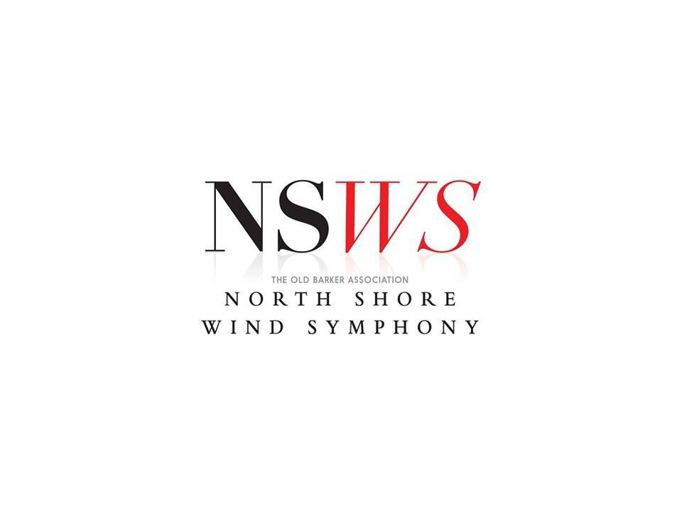
Annual General Meeting
No.9 |  | 17/11/2024
Attendees | Angus Hawken, Amy Bowyer, Warwick Edwards, Liam Mulligan, Andrew Mcwade, Katherine Howarth, Andrew Powell, Eleanor Brimblecombe, Hugo Fahey, Amy Fox, Marcus Paxton, Kaleah Balcomb, Jenny Ridgway, Adrienne Hanslow, Morgan Lacey, Louise Wilson, Katie Proudian, Linda Mitchell, Britney Farrar, River Kim
Apologies
Minutes of the Previous Meeting
- Confirmed previous Minute
  - moved: Linda, Seconded: Warwick

Band Manager’s Report
- Thanks to all
- Felt like the band settled a lot: post-COVID recovery, built on good routines and practises from last year
- Band attendance and members very consistent, proud of culture - new members have settled in very well
- Wished to be at more rehearsals but things got busy.
- Very grateful, thanks to committee - set out to be productive, everyone keen to participate - goals felt fulfilled
- Thanks to MD Andrew for direction
- Highlights:
  - Constitution update: long overdue, uniform & roles all updated
  - Bandforte: made life a lot easier despite some work
  - CreateNSW Grant: Linda did a great job stepping up
  - COncerts:
    - Concert 1 (Con): amazing, learnt a lot from behind the scenes stuff, thanks to everyone helping with percussion
    - States: concert, competition: should all be proud
    - Upcoming concert: glad to have good performance & rehearsal venues
Treasurer’s Report
- started with $12,350 from last AGM
- closed with $14,544.96.
  - $2,354 gain
  - $20,180 revenue (from $12k)
    - ~$10k fees
    - $1200 concert 1 profit
    - $400 grant
    - $250 concert 2
  - $18,385 expenditure (from $13k
    - $7.5k conducting fees
    - $3k music
    - other expenses:
- Both up :)
- Included ticket sales & leftover fees from last year, FIesta concert (upcoming concert will count towards next year)
- ~10 outstanding fees at current
- Successful concerts - the key moving forward.
- Flexible fee system worked well, made treasurer’s job easier.
- Look into more grants next year
- Bandforte helped a lot w/sending out invoices.
- THanks to manager, MD for help
Musical Director‘s Report
- great year, consistent membership & some great new members
- Concert 1: best concert w/ choir
- Cocnert 2: good performance test run.
  - Competition: 2nd place. Discussions about competitions in future should happen.
- Thanks to committee members.
  - Britney: huge effort & enthusiasm as manager. WIll be missed.
- Concert 3: will be great
- Next year will be interesting w/growth of family, Emma might not play
- 10th anniversary next year - concert coming up. Hopefully at con, shared with Barker students.

Secretary Report

- National Band Council of Australia: after NSW left last year things got fun!
- Flute ensemble wanted to compete at Nationals: had to become associate members of the WA band association
- WA voted to leave this year…
- Very fun when wanting to participate in band competitions becomes more difficult. Hopefully things start changing for the better.
- 6 members registered for that in January. Did very well (think they won? Should know haha)
- 66 memberships paid for ahead of States, 1 emergency permit
- Someone wise (myself) decided to go on holidays at the end of term 2… Big thanks to El, Linda, Britney for help with getting everyone registered while I was away. States proceeded with few headaches.
- Full endorsement of Bandforte going forward.
Elections
- Outgoing Committee Members:
  - Band Manager: Britney Farrar
  - Treasurer: Linda Mitchell
  - Librarian: Adrienne Hanslow
  - Secretary: Angus Hawken
  - Personnel Manager: Eleanor Brimblecombe
  - Social Manager: Eleanor Brimblecombe
  - Marketing Officer: Bronte Perrin
  - General Committee (maximum of 5): Calin Hall, Amy Bowyer, Hugo Fahey, Warwick Edwards
  - Paying Ben to run website ☺
- Received nominations for:
  - Band Manager: Linda Mitchell
  - Treasurer: Andrew Powell
  - Librarian: Hugo Fahey
  - Secretary: Angus Hawken
  - Personnel Manager: Eleanor Brimblecombe
  - Marketing & Events Officer: Eleanor Brimblecombe, River Kim
  - General Committee (maximum of 5): Amy Bowyer, Eleanor Brimblecombe, Warwick Edwards, Hugo Fahey, River Kim, Katherine, Amy, Kaleah

Election of 2025 Committee
- Nomination and acceptance of returning officer
- Returning officer: Andrew McWade
- Band Manager: Linda Mitchell
- Treasurer: Andrew Powell
- Librarian: Hugo Fahey
- Secretary: Angus Hawken
- Personnel Manager: Eleanor Brimblecombe
- Marketing & Events Officer: River Kim
- Social Manager: Eleanor Brimblecombe
- General Committee (maximum of 5): Amy Bowyer, Warwick Edwards, Amy Fox, Katherine Howarth, Kaleah Balcomb
Confirmation of who has access to NSWS bank account:
- Linda Mitchell
- Angus Hawken
- Andrew Powell

In line with committee changes, the OBA North Shore Wind Symphony Bank Accounts (held by Commbank) will have Britney Farrar removed as they are not a part of the 2024 committee and Andrew Powell to be added to the account. Linda Mitchell and Angus Hawken will remain on the account as Secretary.
CommBank Account Details:
BSB: 062 - 181
Account: 1089 9979

Member signatures for changes to bank records:
Andrew Powell:

Britney Farrar:

- Other committee reports:  - AB: Thanks to everyone in the committee, everyone keen to help out & much easier to delegate, get things done  - Locking in the programs early helps a lot: everyone locked in & knows whats happening. Encouraging 2025 committee to map out the year ahead like we did this year - especially  - EB: Space for different opinions in the committee & band - everything gets considered. Thanks to Britney for handbook, constitution & everything - thanks to whole committee  - WE: we did good jobs with committee meetings - online, after rehearsals, longer ones - nothing dragged out  - Next year: Could do better with calendar updates - careful when things change, let everyone know a bit better. Planning for things like fathers day, mothers day  - Bandforte: worth looking into more, more benefits - absences, music,  - Constitution update worth doing - maybe more often.  - Christmas party:  - EB: Italian Restaurant, dirty secret santa  - BF: Bowls  - AM: Old & new committee to help out before next concert  - CONSTITUTION:  - changes proposed, provided for members to review previously.  - Motion to accept moved by WE, seconded by LM  - Vote passed. |  |  | - ACTION: LM to sign new constitution.

